

EMPLOYEE LEAVE AND PAYROLL MANAGAMENT SYSTEM – Sprint 3

Course: Software Engineering
Instructor: Ms. Rabail Zahid

Submission Date: 24th April 2026

BY:
The Scytes
Ruhab Ahmad (23I-0559)
Hasan Altaf (23I-0698)
Muhammad Saqib (23I-0769)

SPRINT 3 MODULE
Attendance and Leave Management Module

SPRINT 3 OVERVIEW
Sprint Duration: March 25th, 2026 – April 24th, 2026
Sprint Goal: Implement administrative access controls and individual employee portal functionality.
Modules Developed in Sprint 3: Attendance and Leave Management Module

SPRINT 3 BACKLOG
- List the user stories selected for Sprint 3 using the proper user story template:
US-07 - Record Employee Attendance
As an HR Admin, I want to mark employee attendance so that employee presence is properly tracked.
US-08 - View Attendance History
As an HR Admin, I want to view attendance reports so that I can monitor employee performance and attendance trends.
US-09 - Apply for Leave
As an Employee, I want to submit leave requests so that I can request time off from work.
US-10 - Approve/Reject Leave
As an HR Admin, I want to approve or reject employee leave requests so that leave records remain properly controlled.
US-11 - View Leave History
As an Employee, I want to view my leave status so that I can track whether my leave requests are approved or rejected.
US-12 - Generate Payroll
As an HR Admin, I want to calculate employee salaries so that payroll processing is automated.
US-13 - View Payslip
As an Employee, I want to view my payslip so that I can understand my salary details.
US-14 - Record Salary Advance
As an HR Admin, I want to record salary advance payments so that they can be adjusted in future payroll calculations.
- Include sub-user stories and task breakdowns here.
US-07 – Record Employee Attendance
Sub-User Stories:
- US-07.1 – Mark employee present/absent
- US-07.2 – Select date for attendance
- US-07.3 – View attendance status before saving
- US-07.4 – Save attendance record
Task Breakdown:
- Design attendance marking UI
- Create backend API to store attendance
- Implement date selection feature
- Add present/absent toggle or selection option
- Validate attendance entries (no duplicates for same day)
- Connect frontend with backend API
- Testing (attendance marking flow + validation)
US-08 – View Attendance History
Sub-User Stories:
- US-08.1 – View full attendance records list
- US-08.2 – Filter by employee
- US-08.3 – Filter by date range
- US-08.4 – View attendance summary
Task Breakdown:
- Design attendance history UI
- Create API to fetch attendance data
- Implement filtering by employee
- Implement date range filtering
- Display summary (present/absent count)
- Connect frontend with backend APIs
- Testing (filtering + data accuracy)
US-09 – Apply for Leave
Sub-User Stories:
- US-09.1 – Fill leave request form
- US-09.2 – Select leave type (casual/sick/etc.)
- US-09.3 – Select start and end date
- US-09.4 – Submit leave request
Task Breakdown:
- Design leave application form UI
- Create backend API for leave request submission
- Implement leave type selection
- Add date validation (end date ≥ start date)
- Store leave request in database
- Connect frontend with backend API
- Testing (form validation + submission flow)
US-10 – Approve/Reject Leave
Sub-User Stories:
- US-10.1 – View pending leave requests
- US-10.2 – Approve leave request
- US-10.3 – Reject leave request with reason
- US-10.4 – Update leave status
Task Breakdown:
- Design leave approval dashboard UI
- Create API to fetch pending requests
- Implement approve/reject actions
- Add optional rejection reason input
- Update leave status in database
- Notify employee of decision (optional)
- Testing (approval workflow + edge cases)
US-11 – View Leave History
Sub-User Stories:
- US-11.1 – View all submitted leave requests
- US-11.2 – View approval status
- US-11.3 – Filter by leave type/status
- US-11.4 – View detailed leave record
Task Breakdown:
- Design leave history UI
- Create API to fetch employee leave data
- Implement filtering by status/type
- Display leave request details view
- Connect frontend with backend APIs
- Testing (data accuracy + filters)
US-12 – Generate Payroll
Sub-User Stories:
- US-12.1 – Select payroll period
- US-12.2 – Fetch employee salary data
- US-12.3 – Calculate net salary
- US-12.4 – Generate payroll records
Task Breakdown:
- Design payroll generation UI
- Create backend API for salary calculation
- Fetch employee salary + deductions data
- Implement payroll calculation logic
- Store generated payroll records
- Connect frontend with backend API
- Testing (calculation accuracy + payroll generation)
US-13 – View Payslip
Sub-User Stories:
- US-13.1 – View monthly payslip list
- US-13.2 – Select specific payslip
- US-13.3 – View salary breakdown
- US-13.4 – Download/print payslip
Task Breakdown:
- Design payslip UI
- Create API to fetch payslip data
- Display salary breakdown (basic, deductions, net salary)
- Implement download/print functionality
- Connect frontend with backend APIs
- Testing (data correctness + export feature)
US-14 – Record Salary Advance
Sub-User Stories:
- US-14.1 – Enter employee advance details
- US-14.2 – Specify amount and date
- US-14.3 – Store advance record
- US-14.4 – Reflect deduction in payroll
Task Breakdown:
- Design salary advance entry form UI
- Create backend API for advance recording
- Validate amount and employee ID
- Store advance in database
- Integrate with payroll deduction logic
- Connect frontend with backend API
- Testing (data entry + payroll impact)

STRUCTURED SPECIFICATIONS
US-07 – Record Employee Attendance
Inputs:
- Employee selection
- Attendance status (Present/Absent)
- Date of attendance
Processing:
- Validate HR Admin authentication
- Check for duplicate entry for same employee/date
- Save attendance record in database
- Confirm successful entry
Outputs:
- Attendance record saved successfully
- Confirmation message displayed
Preconditions:
- User must be logged in as HR Admin
- Employee must exist in system
Postconditions:
- Attendance data is stored in database

US-08 – View Attendance History
Inputs:
- Request from HR Admin
- Optional filters (employee/date range)
Processing:
- Validate authentication
- Fetch attendance records from database
- Apply filters if provided
- Format data for reporting
Outputs:
- Attendance history displayed
- Filtered results shown (if applied)
Preconditions:
- User must be logged in as HR Admin
- Attendance records exist
Postconditions:
- Attendance data is displayed successfully
US-09 – Apply for Leave
Inputs:
- Leave request form data
- Leave type, start date, end date, reason
Processing:
- Validate employee authentication
- Validate input fields and date range
- Save leave request in database with “Pending” status
- Notify HR Admin (optional)
Outputs:
- Leave request submitted successfully
- Confirmation message shown
Preconditions:
- User must be logged in as Employee
- Employee account must be active
Postconditions:
- Leave request stored in system as pending
US-10 – Approve/Reject Leave
Inputs:
- Leave request ID
- HR decision (Approve/Reject)
- Optional rejection reason
Processing:
- Validate HR Admin authentication
- Fetch leave request
- Update status in database
- Store decision and reason (if any)
- Notify employee
Outputs:
- Updated leave status (Approved/Rejected)
- Confirmation message displayed
Preconditions:
- User must be logged in as HR Admin
- Leave request must exist
Postconditions:
- Leave request status is updated
US-11 – View Leave History
Inputs:
- Request from employee
- Optional filters (status/type/date)
Processing:
- Validate employee authentication
- Fetch leave records from database
- Apply filters if provided
- Format results for display
Outputs:
- List of leave requests with status
Preconditions:
- User must be logged in as Employee
- Leave records must exist
Postconditions:
- Leave history is displayed successfully
US-12 – Generate Payroll
Inputs:
- Payroll period selection
- Employee salary and deduction data
Processing:
- Validate HR Admin authentication
- Fetch employee salary details
- Apply deductions and advances
- Calculate net salary
- Store payroll records
Outputs:
- Payroll generated successfully
- Payroll summary displayed
Preconditions:
- User must be logged in as HR Admin
- Employee salary data must exist
Postconditions:
- Payroll records are stored in system
US-13 – View Payslip
Inputs:
- Employee request for payslip
- Selected month/year
Processing:
- Validate employee authentication
- Fetch payroll record
- Format salary breakdown
- Prepare payslip view
Outputs:
- Payslip displayed on screen
- Option to download/print
Preconditions:
- User must be logged in as Employee
- Payroll data must exist
Postconditions:
- Payslip is successfully viewed
US-14 – Record Salary Advance
Inputs:
- Employee ID
- Advance amount
- Date of advance
Processing:
- Validate HR Admin authentication
- Validate amount and employee existence
- Store advance record in database
- Link advance to payroll deduction
Outputs:
- Salary advance recorded successfully
Preconditions:
- User must be logged in as HR Admin
- Employee must exist
Postconditions:
- Advance is stored and applied in payroll calculations

SCRUM BOARD
- Initial backlog uploaded:
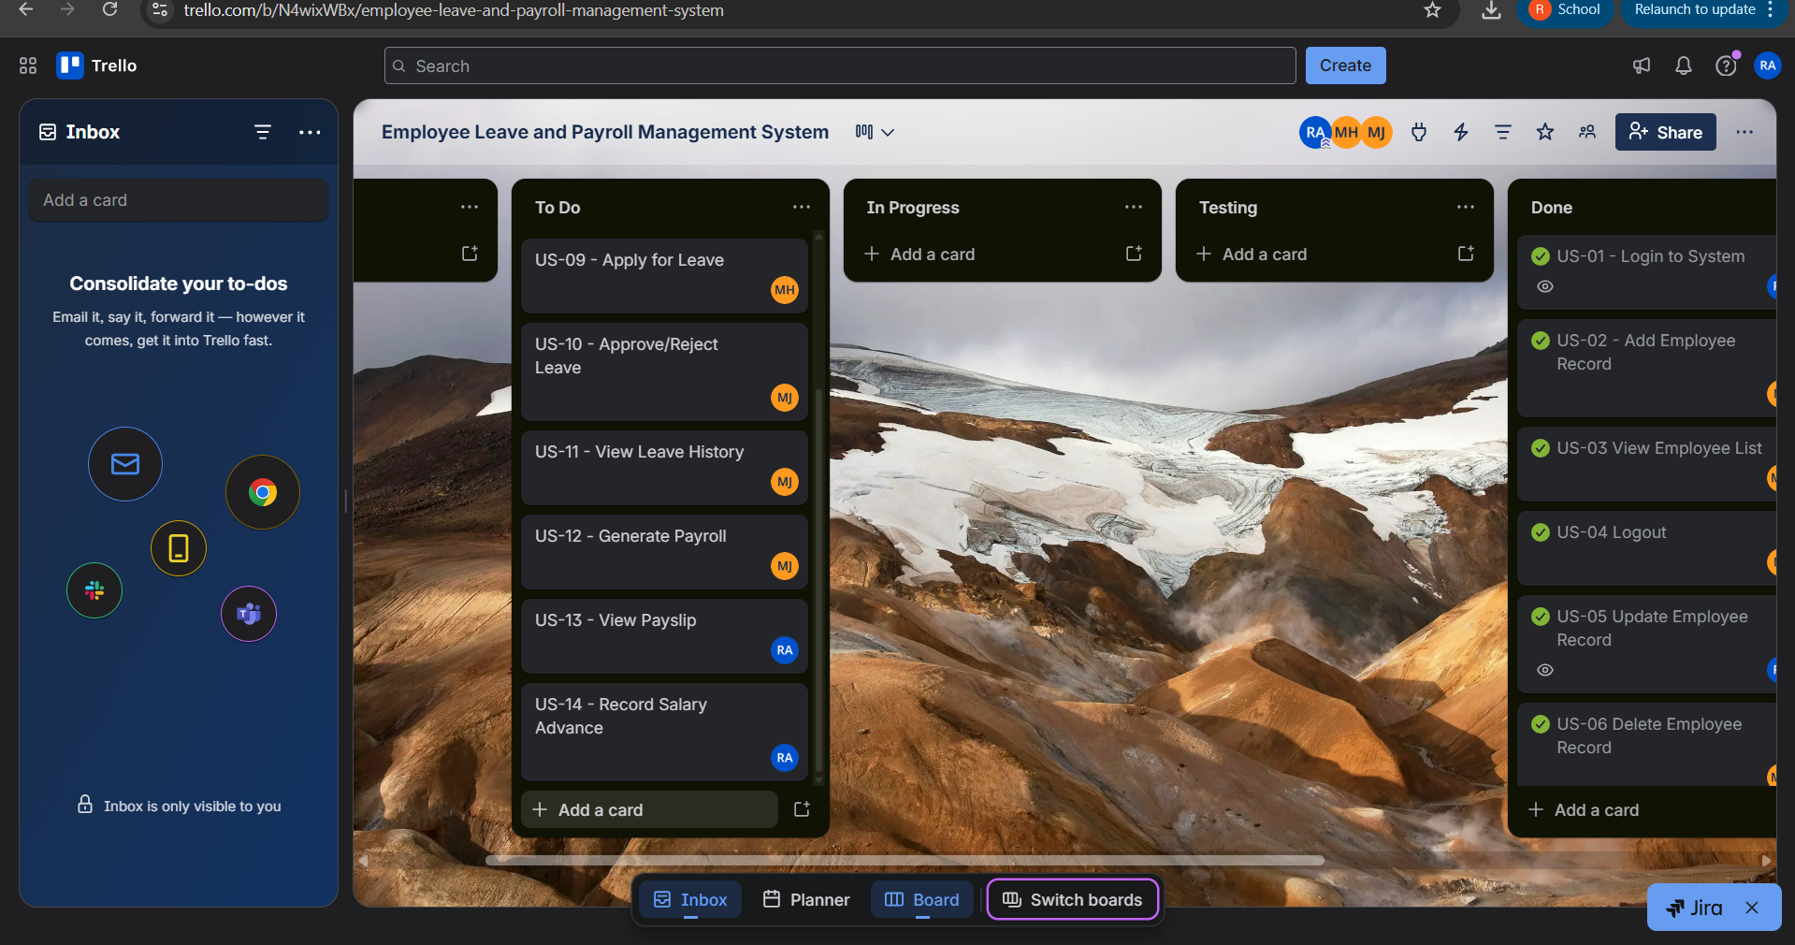
- Mid-sprint progress:
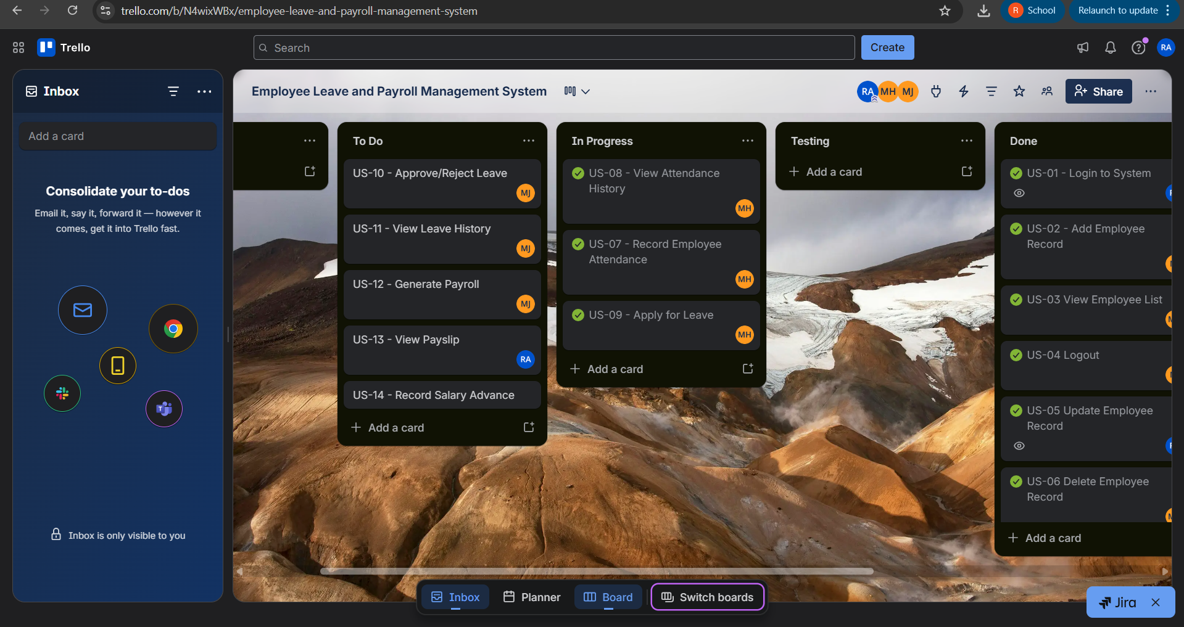
- Final sprint status:
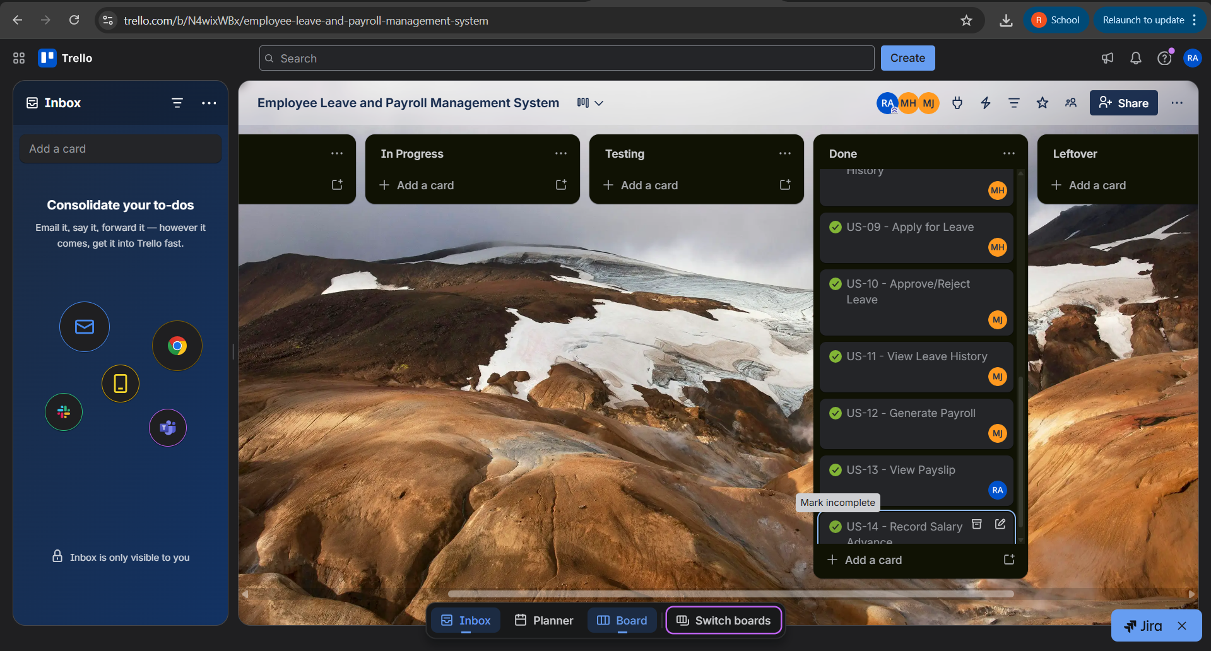

PRODUCT BURN DOWN CHART
